Assessing the Impacts of Damming and Drought on Discharge Variability of the Tigris and Euphrates Rivers (1979–2022)
Mohsen Bakhtiari ^{a, b}, Najmeh Neysani Samany ª, Sarmad Dashti Latif ^{c}, Ali Darvishi Boloorani ^{a*}
ª Department of Remote Sensing and GIS, Faculty of Geography, University of Tehran, Tehran, Iran
^{b} General Department of Natural Resources and Watershed Management of Alborz Province, Karaj, Iran
^{c} Civil Engineering Department, College of Engineering, Komar University of Science and Technology, Sulaimany, Kurdistan Region, Iraq
*corresponding author (ali.darvishi@ut.ac.ir)

Abstract: The Tigris and Euphrates Basin (TEB) face severe water challenges driven by extensive dam construction, prolonged droughts, and intensifying climate change. This study analyzes river discharge variations from 1979 to 2022 to identify the relative effects of damming and prolonged droughts. Using daily discharge data from 24 sites (12 proximal and 12 distal to major dams) and monthly Palmer Drought Severity Index (PDSI), we applied time series and statistical analysis and change point studies for pre‑ and post‑damming periods. Results indicate substantial discharge reductions, altered flow regime in both Tigris and Euphrates rivers, and strong discharge–drought correlations was observed. Proximal sites show abrupt decreases linked to dam operations, while distal ones reveal gradual declines shaped by both factors. Lower discharge correlations at proximal sites reflect dam regulation, whereas stronger seasonal correlations at distal points relate to precipitation patterns. Overall, damming creates immediate localized impacts, while drought drives broader basin‑wide decline of water flow. These findings highlight the need for integrated water resources management that accounts for both water resources management and climate variability between riparian countries (Türkiye, Iraq, Syria, and Iran) to sustain future water security in the TEB.
Key words: Tigris and Euphrates Basin (TEB), discharge, drought, damming, climate change.
- Introduction
Dams fundamentally alter the natural flow regime of rivers by acting as physical barriers that impound water, thereby creating reservoirs (Petts, 1984; Shiklomanov, 1997; Graf, 2006; Kim, 2026; González-Cao et al., 2026). Globally, there are more than 2.8 million medium-sized and large dams which altered flow regime and longitudinal connectivity on the majority of the rivers (Kondolf & Yi, 2022). Only 23% of rivers longer than 1,000 kilometres flow continuously to the ocean, and only 37% of rivers continue to flow freely over their whole course. This statistic was reported based on an assessment of the connection status of 12 million kilometres of rivers worldwide (Grill et al., 2019). This impoundment inherently disrupts the natural patterns of river flow, leading to what is known as flow regulation (Ward & Stanford, 1995; Stoffers et al., 2026). Flow regulation involves the storage of water during periods of high discharge, such as wet seasons or flood events, and the subsequent release of the stored water during periods of low discharge, such as dry seasons or droughts (Wen et al., 2011; Lu et al., 2021). The primary aim of this regulation is to meet various human demands, including water supply for domestic and industrial uses (Adamo et al., 2020), irrigation for agriculture, the generation of hydroelectric power, and the mitigation of flood risks (Kibaroglu & Scheumann, 2013). Dams typically reduce the peak flood discharge downstream by effectively storing a portion of the floodwaters within the reservoir. Conversely, during dry seasons, dams can increase the discharge downstream by releasing the water that was stored during wetter periods, which can lead to a more homogenized flow regime throughout the year. However, the extent of these changes depends largely on several factors, including the dam size and reservoir capacity, the operational rules that prioritize objectives such as hydropower generation or irrigation supply, and the broader water management strategy adopted within the river basin (Graf, 2006, Voss et al., 2013; Sun et al., 2025). Furthermore, dams tend to flatten the natural variability of river discharge over time (Shiklomanov, 1997). In addition to these seasonal or event-based changes, dams can also introduce unnatural short-term fluctuations in discharge. These rapid changes in river flow are frequently driven by operational needs, especially in the case of hydroelectric dams, where water releases are adjusted to meet peak electricity demands. Such modifications can significantly alter the timing of naturally occurring high and low flow periods. These shifts can have profound implications for the ecological cues that many aquatic and riparian species rely upon for critical life cycle events, including migration, spawning, and germination (Ward & Stanford, 1995; Eiriksdottir et al., 2017; Kamidis et al., 2021).
The Tigris and Euphrates Basin (TEB), a region of immense historical and ecological significance in the Middle East, have sustained human civilizations for millennia (Altinbilek, 2004; Zargar & Abbasi Alamooti, 2023). These rivers, originating in Turkey and flowing through Syria and Iraq to the Persian Gulf, are the lifeblood of an arid and semi-arid landscape, supporting agriculture, providing essential water supplies, and sustaining diverse ecosystems (Issa et al., 2013). In recent decades, however, the basin has experienced increasing water stress due to large-scale damming projects, particularly within Turkey, and the growing threat of climate change manifested as prolonged and intensified droughts (UN-ESCWA, 2013; Ozguler & Yıldız, 2020; Darvishi Boloorani, et al., 2026; Latif, 2026). The Southeastern Anatolia Project (GAP), initiated by the Turkish government, represents a massive undertaking involving the construction of 22 dams, 19 hydroelectric plants (7640 MW capacity, 27 billion kWh annual output), and irrigation networks covering 1.7 million hectares on both rivers (Tigris-Euphrates) (Unver, 1997; Hussein & Mohamed, 2021; Bilgen & Mason, 2026). Key structures such as the Atatürk dam on the Euphrates River and the Ilisu dam on the Tigris River have significantly altered the natural flow regimes of these rivers, leading to concerns about water availability and quality in downstream Syria and Iraq (Beaumont, 1978; Warner, 2012; Al-Hudaib et al., 2025; Zaghiyan et al., 2026). While Turkey emphasizes the benefits of these projects for energy production and irrigation within its borders, the scale of these interventions has raised significant geopolitical and environmental issues in the region (Oktav, 2017; Luan et al., 2025). Iraq, being the furthest downstream riparian state, has consistently claimed significant reductions in its historical water supply from both the Tigris and Euphrates rivers since the 1970s, coinciding with the intensification of Turkish dam construction. The magnitude of the reported flow reductions is substantial, although estimates can vary across different study areas and time periods. For the Euphrates River, reductions of 40% or even greater in discharge have been reported following the completion of major dams like the Atatürk. Similarly, the flow of the Tigris River is anticipated to decrease significantly, potentially by as much as 50% of its historical average, once all planned Turkish dams within the GAP project become fully operational. Beyond the overall reduction in water quantity, the seasonal flow patterns of both rivers have also been demonstrably altered. These alterations typically involve a reduction in the magnitude of peak flows that historically occurred during the spring months due to snowmelt and rainfall in the upper catchments. The extensive damming has also led to instances of significant deviations from historical flow norms, including concerns about potential flow cessation in the Euphrates River within Iraq. Some projections suggest that the Euphrates could face the risk of drying up within Iraqi territory by the year 2040, a dire consequence attributed to a combination of upstream damming and the increasing impacts of climate change and drought on regional water availability (Abdelmohsen et al., 2022; Hashemi et al., 2024; Al- Shaabani & Nashed, 2025; Darvishi Boloorani et al., 2026). The reduced water flow, particularly the decrease in seasonal flooding, has had a devastating impact on the vital Iraqi marshes located in the lower reaches of the river basins, leading to their significant destruction and the disruption of the unique ecosystems and livelihoods they once supported (Issa et al., 2013). Dam construction and increasing regional droughts have jointly altered the hydrological balance, reducing downstream water availability and contributing to the desiccation of marshes and wetlands (Beaumont, 1978; Unver, 1997; El-Fadel et al., 2002; UN-ESCWA, 2013; Al-Ansari et al., 2019; Azizi & Leandro, 2025; Darvishi Boloorani et al., 2026; Latif, 2025), which in turn become active dust sources as wind erodes exposed soils and triggers dust storm events (Bakhtiari et al., 2021; Darvishi Boloorani et al., 2021).
This study analyzes 44 years (1979–2022) of discharge changes in the Tigris and Euphrates rivers to assess the respective and combined impacts of upstream damming and climate-induced drought. Using hydrological and statistical methods on daily discharge data from 12 proximal points near major dams and 12 distal downstream points, along with monthly Palmer Drought Severity Index (PDSI) data, the study quantifies how these factors have altered river flow regimes. Understanding their interplay is crucial for sustainable water resources management and mitigating potential conflicts in this water-scarce and politically sensitive basin. The novelty of this study lies in the long-term comparative assessment of discharge dynamics in proximal and distal locations relative to major dams over a 44-year period, enabling a clearer separation of dam-induced hydrological alterations from climate-driven drought signals in the TEB.

- Material and Methods
  - Study Area
The Tigris and Euphrates rivers originate in the eastern Anatolian highlands of Turkey and flow southeast through Syria and Iraq before converging at Al-Qurnah to form the Arvand Rud (called Shatt al-Arab in Iraq), which drains into the Persian Gulf (Altinbilek, 2004; Kibaroglu & Scheumann, 2013). The basin’s elevation ranges from sea level to nearly 4000 m in the northern and northeastern highlands (Figure 1), with precipitation and temperature largely controlled by altitude and latitude. The Tigris and Euphrates Basin (TEB) exhibit sharp climatic gradients—from humid mountain headwaters to arid and semi-arid plains. These rivers provide vital freshwater for agriculture, ecosystems such as the Mesopotamian Marshes, and dense human populations (Issa et al., 2013; Al-Ansari et al., 2018).
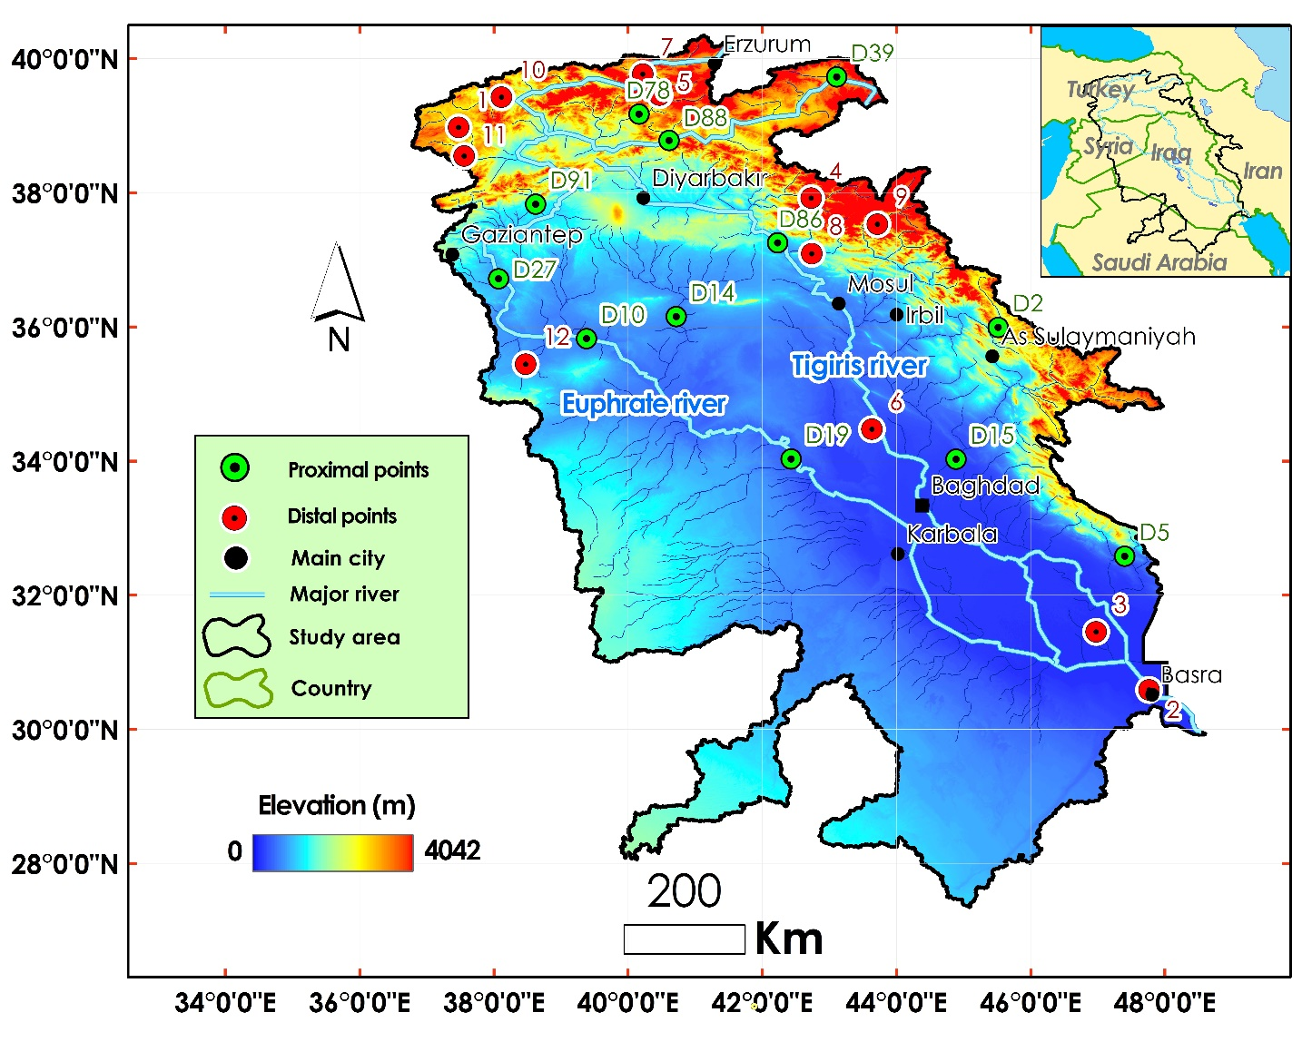
Figure 1. The study area Tigris and Euphrates Basins (TEB), shows the main dams (D numbers are explained in table 1) and proximal and distal discharge measuring points.

  - Datasets
Dam characteristics of 12 main dams, which compiles reservoirs exceeding 0.1 km³ capacity (Lehner et al., 2011), including construction year, storage volume, and operational status, are summarized in Table 1.
Table 1. The main characteristics of 12 dams in the TEB extracted from the Global Reservoir and Dam Database (GRanD) (Lehner et al., 2011).
No. | Dam Code* | Name | River | Basin | Country | Operation year | Functions | Volume (MCM)
1 | D19 | Haditha | Euphrates | Euphrates | Iraq | 1987 | Irrigation/ Hydro Power | 8280
2 | D39 | Yazici | Altincayir |  | Turkey | 2009 | Irrigation | 196
3 | D88 | Lower Kaleköy | Murat |  |  | 2019 | Hydro Power | 516.5
4 | D27 | Karkamis | Euphrates |  |  | 2000 | Hydro Power/ Flood Control | 160
5 | D91 | Srmtaş | Birimşe |  |  | 2013 | Hydro Power | 60
6 | D78 | Yedisu | Peri |  |  | 2012 | Hydro Power | 5
7 | D86 | Ilısu | Tigris | Tigris |  | 2018 | Irrigation/ Hydro Power/ Flood Control | 10410
8 | D10 | Baath | Euphrates | Euphrates | Syria | 1987 | Irrigation/ Hydro Power/ Flood Control | 90
9 | D14 | Al Assad | Khabur |  |  | 2001 | Irrigation | 605
10 | D15 | Hamrin | Diyala | Tigris | Iraq | 1981 | Irrigation/ Flood Control | 2450
11 | D2 | Sardasht | Lesser_Zab |  | Iran | 2017 | Irrigation/ Hydro Power | 387
12 | D5 | Dwairej | Dwairej |  |  | 2013 | Irrigation | 205
*Dam codes are based on the Global Reservoir and Dam Database (GRanD)
Daily discharge (1979-2022) dataset provides a modelled time series of river network discharges generated using the open-source hydrological model LISFLOOD, designed for hydrological, flood, and drought analyses (Harrigan et al., 2020). Data were obtained from 24 sampling points (12 proximal and 12 distal) along the Tigris and Euphrates rivers (Figure 1). Proximal sites were selected near major dams to assess the immediate effects of dam operations, while distal ones—located farther downstream—capture broader Meteorological-Agricultural drought and tributary influences. The daily resolution enables assessment of both short-term variability and long-term discharge trends.
As the indicator of both Meteorological and Agricultural droughts, the Monthly Palmer Drought Severity Index (PDSI) (1979-2022) integrates temperature, precipitation, and potential evapotranspiration in a soil–water balance model to quantify drought severity and persistence (Abatzoglou et al., 2018; Dai, 2011). PDSI was used to evaluate long-term drought impacts on river discharge and to compare drought sensitivity between sampling points near and far from dams.
  - Methodology
This study analysed the discharge variations of 12 proximal and 12 distal points along the rivers to investigate the hydrological impacts of damming and drought on discharge variability in the Tigris–Euphrates rivers (1979–2022). As showed in Figure 2, the research methodology follows the main steps as follows:
- Daily discharge data were examined using Time Series Analysis (TSA) to identify long-term patterns and regime shifts of the water follows. TSA methods capture relationships between a time series and its temporal lagged values, revealing temporal dependencies and hydrological interrelations (Haas et al., 2009; Shamseddin & Elmeski, 2022; Fu et al., 2024). The Breaks for Additive Season and Trend (BFAST) model decomposes time series into trend, seasonal, and residual components, effectively detecting structural changes in discharge (Richter et al., 1996; Piwowar & LeDrew, 2002; Verbesselt et al., 2010; Geng et al., 2019; Li et al., 2022; Mendes et al., 2022). These methods were used to quantify variations in average flow and identify significant change periods across the 44-year (1979–2022) record for both sample point groups.
- To evaluate drought–discharge relationship, Pearson’s correlation coefficients were computed between monthly discharge and PDSI values (Nielsen, 2002; Dai, 2011). This analysis assessed the strength and direction of linear relationships, indicating how drought conditions influence river flow at varying proximities to major dams.
- Change point analysis was employed to detect statistically significant shifts in mean discharge and relate them to dam operation timelines, including two main dams of the TEB, the Atatürk (early 1990s) and Ilisu (2019) dams (Kibaroglu & Scheumann, 2013). Discharge characteristics before and after dam operation were compared to evaluate hydrological alterations. Differences in magnitude, seasonal variability, and drought correlations between proximal and distal points helped distinguish local dam effects from broader drought influences.
- Finally, the main findings of the project were analysed to assess the impacts of damming and drought on the discharge variability of the Tigris and Euphrates rivers (1979–2022).
- 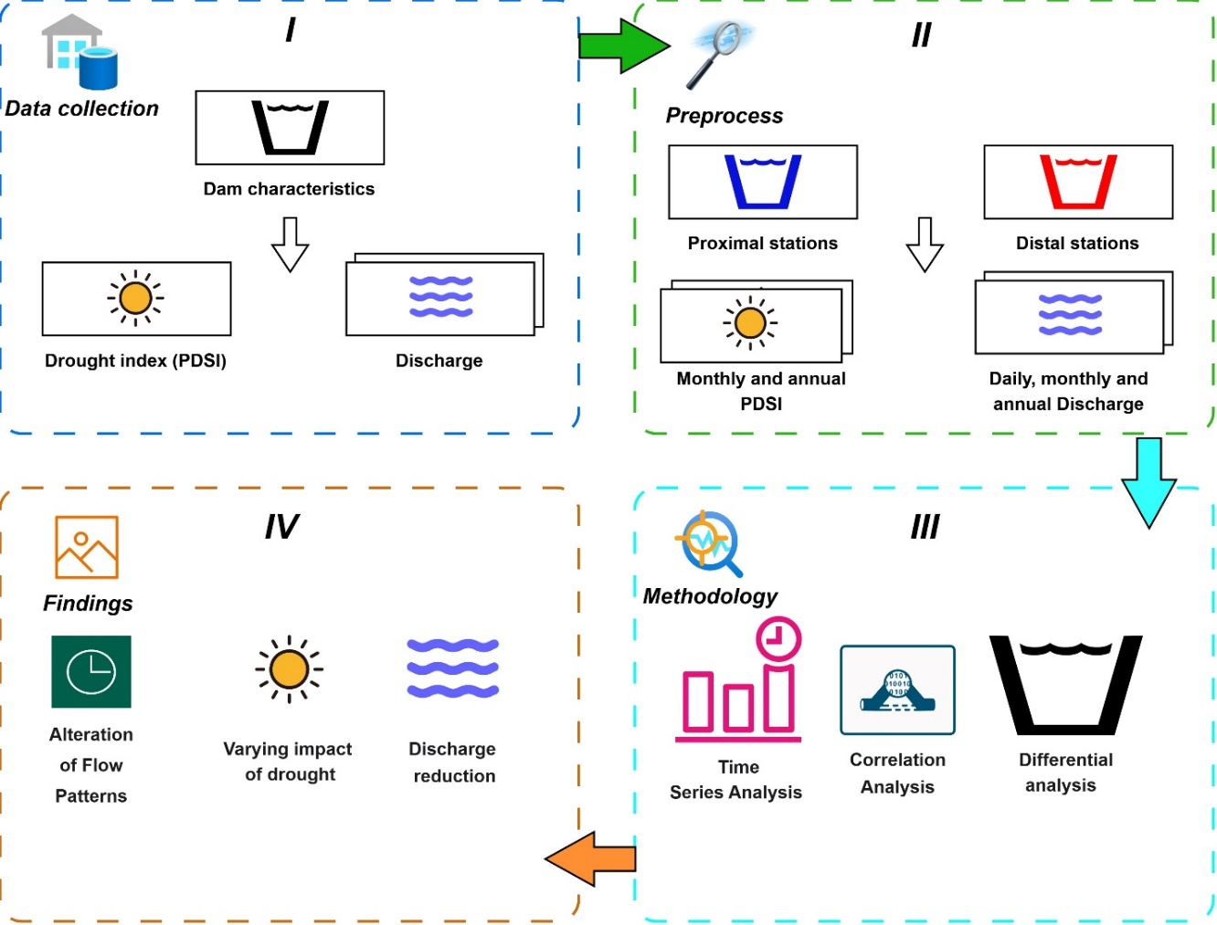
Figure 2. Flowchart of general steps of the study to assess the impacts of damming and drought on discharge variability in the Tigris–Euphrates Rivers (1979–2022).
- Results
  - Annual changes of river discharge and drought
The change of monthly discharge (m³/s) and Palmer Drought Severity Index (PDSI) (roughly from about −10 to +10) for 12 proximal and 12 distal sampling points along the main rivers of TEB during 1979 to 2022, were set and displayed in Figure 3 and Figure 4, respectively. the PDSIs were categorized into 8 classes from extreme dry (highest red vertical dash line) to extreme wet times (highest blue vertical dash line).
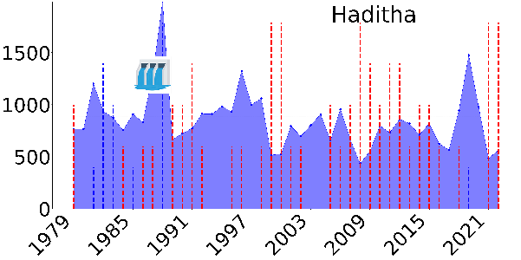 | 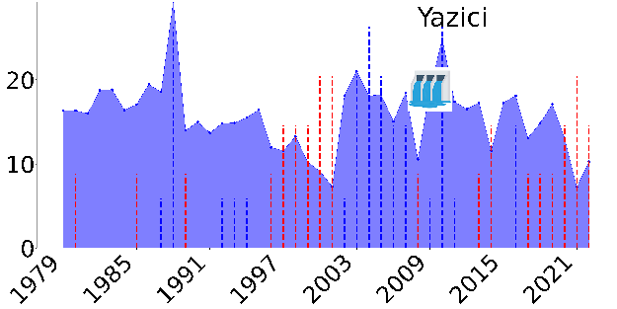 | 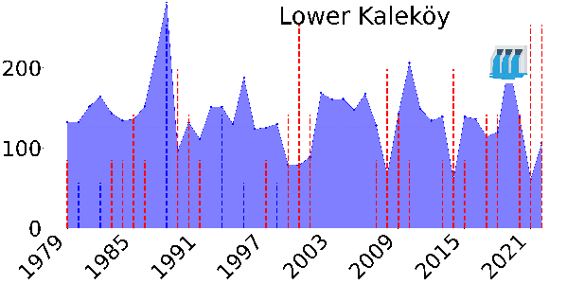
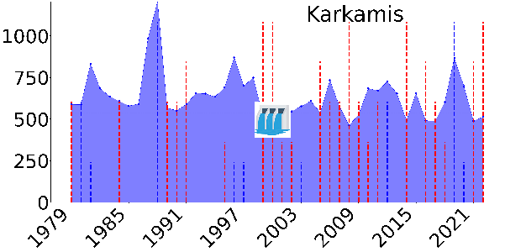 | 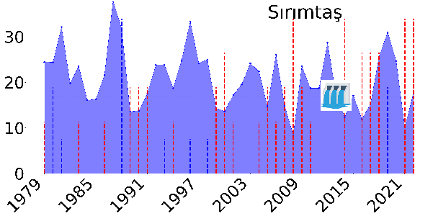 | 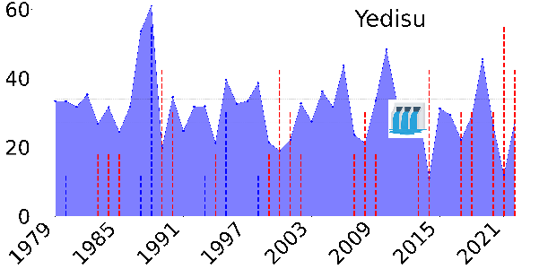
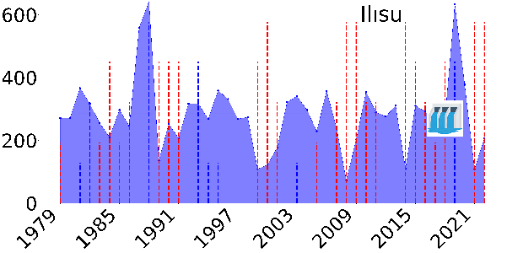 | 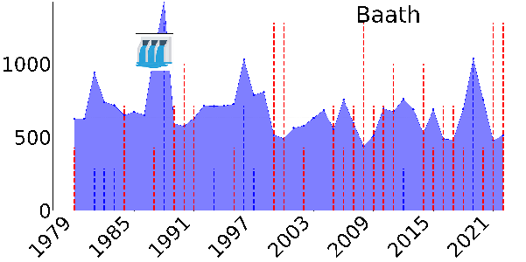 | 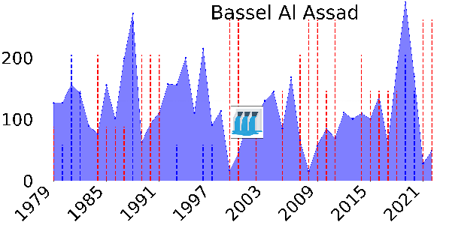
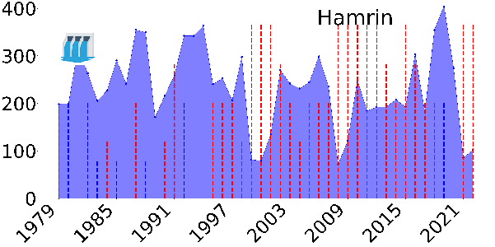 | 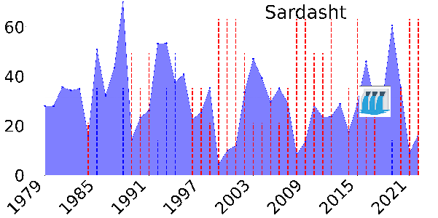 | 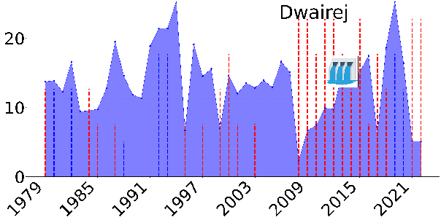
Figure 3. Annual discharge (m³/s) and PDSI changes of proximal stations (i.e., dam outlet) from 1979 to 2022. PDSIs were categorized into 8 classes from extremely drought (highest red vertical dash line) to extremely wet (highest blue vertical dash line).  shows year of dam operation.

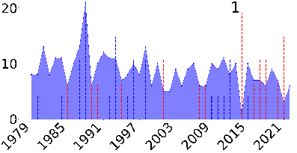 | 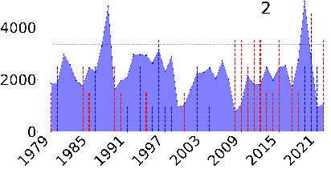 | 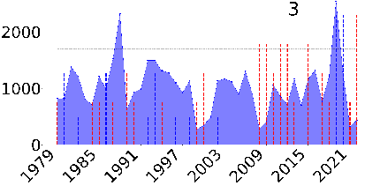
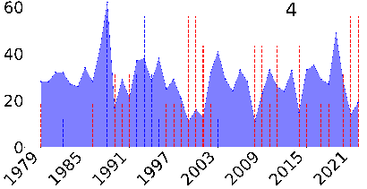 | 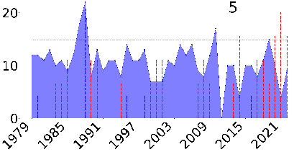 | 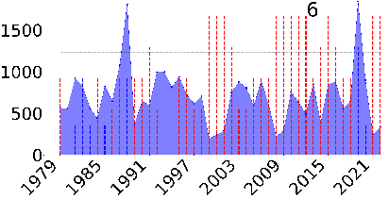
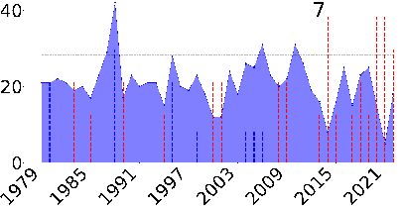 | 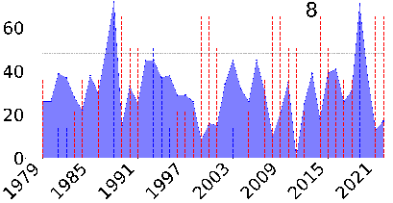 | 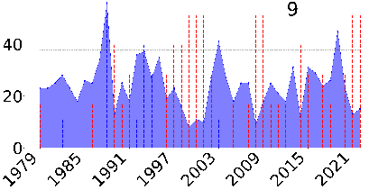
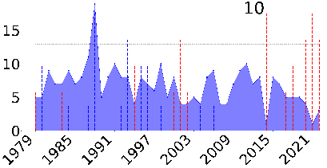 | 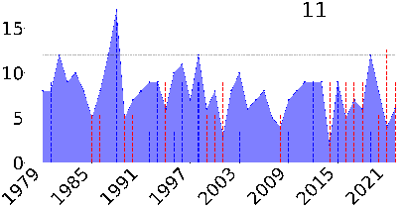 | 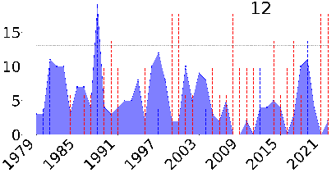
Figure 4. Annual discharge (m³/s) and PDSI changes of the distal stations during 1979 to 2022. PDSIs were categorized into 8 classes from extremely drought (highest red vertical dash line) to extremely wet (highest blue vertical dash line).  shows year of dam operation.

Annual average discharge values of proximal points before and after dam construction are compared in Figure 5-a. A significant reduction of discharge was observed across all those sample points during the post-damming period. Annual standard deviation of proximal points discharges within the 2 periods was used as index of discharge fluctuation. It disclosed an increment in average discharge fluctuation (m³/s) for most points (Figure 5-b).
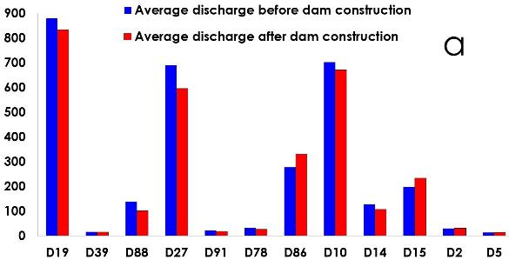 | 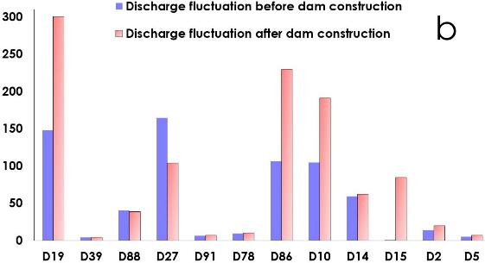
Figure 5. Average discharge (m³/s) (a) and discharge fluctuation (m³/s) (b) of the proximal sample points of TEB rivers before and after dams’ operation.

  - Monthly discharge trends
To perform flow trending, first, the Mann–Kendall test was implemented on the monthly discharge series at the proximal points. Then, trending was performed using the BFAST on the monthly discharge time series at points with a valid trend. Monthly trends of proximal points and the trend and seasonality components for those time series were estimated. Resultes revealed that 8 of the 12 proximal sample points had a significant monthly flow trend between 1979 and 2022, with the exception of Khabour dam in northeastern Syria on the Euphrates River, the remaining points had experineced a decreasing monthly trend.
Monthly discharge trends of proximal points from 1979 to the year of dam operation including, the trend and seasonality components of time series show only 2 points: Lower Kaleköy and Ilissu have experineced a decreasing monthly flow trend during the period, while the remaining ones had no trend. Monthly trends of proximal points during the year of dam construction to 2022 confirmed that 5 locations witnessed a decreasing monthly flow trend during the studied period. Monthly trends of distal points to dams during 1979 to 2022 and their corresponding trend and seasonality components show that 10 points experienced a decreasing monthly flow trend, while only 2 of them had no trend.
  - Drought impacts on rivers discharge
Average PDSI changes before and after dam construction, consistently shows lower PDSI values after dam operation across all proximal sampled points (Figure 6- a), indicates an increase in drought impacts downstream of the dams. Average PDSI for distal points during 1979 to 2022 are shown in Figure 6-b. Average PDSI of proximal points during 1979- 2022, before and after dam operation were -1.3, -0.50 and -2.10, respectively, while it was -0.82 for distal points. Therefore, the PDIS changes directly implies a worsening of drought conditions, especially in downstream after dam constructions.
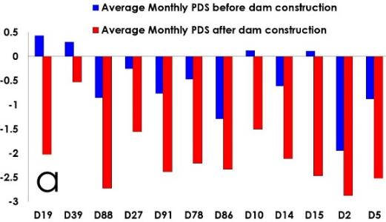 | 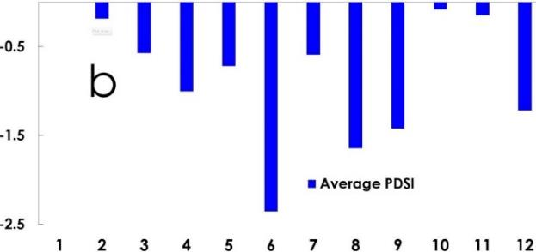
Figure 6. Average PDSI values before (blue) and after (red) dam constructions for proximal (a) and distal sapling points from 1979 to 2022 (b).
  - Relationship between annual discharge and PDSI
To measure the relationship between drought and monthly discharge, the R² values for before and after dam operations was calculated. Results (Figure 7) reveals that the correlation between PDSI and discharge in the period after construction of dams was higher than before dam operation; where, the general trends of drought and monthly discharge after damming were decreasing. The only exception is the Srmtaş (D91) station in the northwest of TEB because of its lower sensitivity of discharge to climatic and drought conditions, so that the correlations in the two periods did not differ much from each other. Points with sensitivity to drought show greater correlation between discharge and drought after dam operation.
The results of the correlation between the monthly drought and discharge of distal points generally show that the correlation between PDSI and monthly discharge for points 1, 10, 11, and 12, located in the northwest of TEB, are higher than for 2 and 3 points, which are in the southeast of TEB. This difference is noticeable, as points 2 and 3 have a much higher average discharge than 1, 10, 11, and 12 (over 100 m³/s compared to about 20 m³/s), which are less affected by meteorological drought. Therefore, the correlation between discharge and drought is higher at points with a lower average discharge, due to the higher impact of drought on discharge.
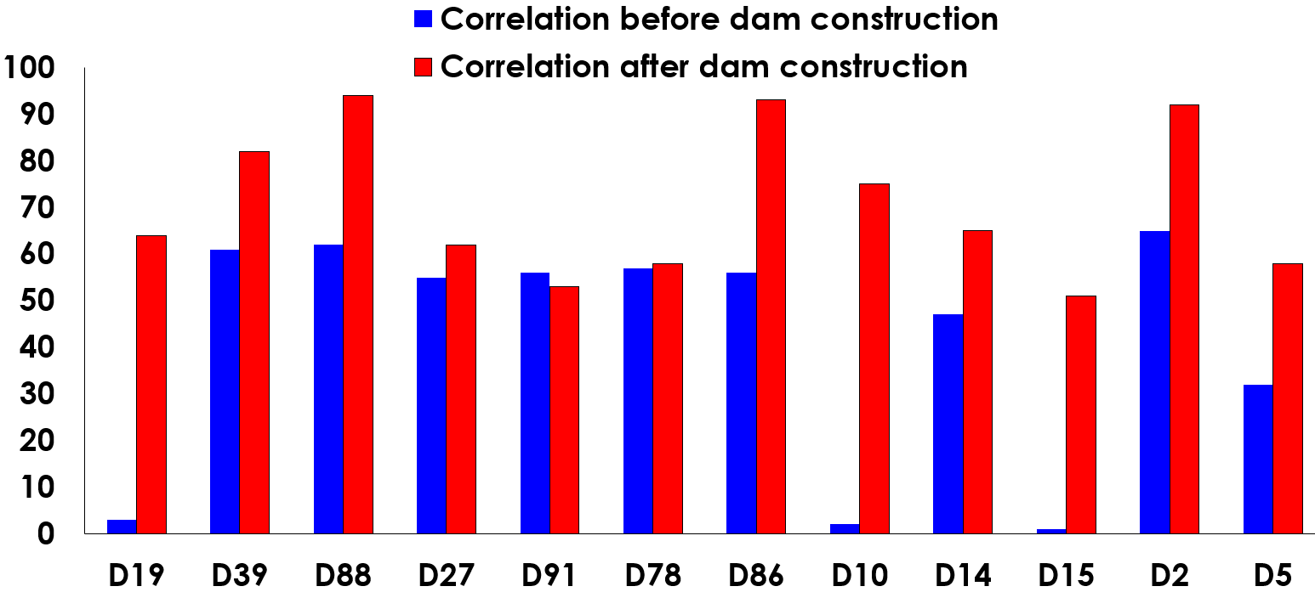
Figure 7. Correlation between PDSI and discharge through before and after dam construction for 12 proximal points to dams.

- Discussion
The analysis of the discharge and PDSI time series from 1979 to 2022, revealed significant changes in the flow regimes of both the Tigris and Euphrates rivers, with distinct influences from damming and drought observed at both proximal and distal points to dams in the whole Tigris and Euphrates basin. A significant decline in average discharge was observed in both rivers across all studies points, with the sharpest reductions at the 12 points close to the dams. Distal points also showed decreases, though more gradual. The marked drop in downstream flow aligns with expected dam impacts—water impoundment, regulated releases, and increased evaporation. Notably, the Ilisu dam station exhibited lower flows even before impoundment, likely due to construction-related disruptions. PDSI analysis indicates intensified drought conditions at proximal points after dam operation, suggesting either a regional shift toward drier conditions or feedback from reduced surface water. Overall, the results highlight how dam operations amplify drought effects and reduce downstream water availability.
River discharge showed a strong positive correlation with PDSI at both proximal and distal points. The correlation was higher at distal points, indicating stronger drought influence linked to climatic and damming effects. Near-dam points displayed discharge patterns closely tied to dam operations, with climate impacts becoming more pronounced post-dam-construction.
The average slopes of monthly discharge trends for both proximal and distal points across three periods—1979–2022, pre-dam (from 1979 to year of dam operation), and post-dam (from dam operation to 2022)—are shown in Figure 8. The post-dam period exhibits a steeper negative slope at proximal points, reflecting a stronger reduction in discharge downstream of dams. Although both point groups show similar slope magnitudes, distal points have a higher number of valid discharge trends over the long-term record, likely due to the extended data period.
Damming projects caused more immediate and pronounced alterations in flow regimes at proximal points, including reduced peak flows and shifts in seasonal timing, making downstream flow prediction more difficult. Distal sample points also showed seasonal changes, but these were moderated by tributary inputs and regional climate influences. Change point analysis confirmed earlier and more significant declines in mean discharge at proximal points, coinciding with dam operation years, while distal points showed delayed and smaller declines. Overall, the estimated percentage reduction in average annual discharge was substantially higher in the proximal points than the distant points (Figure 8).
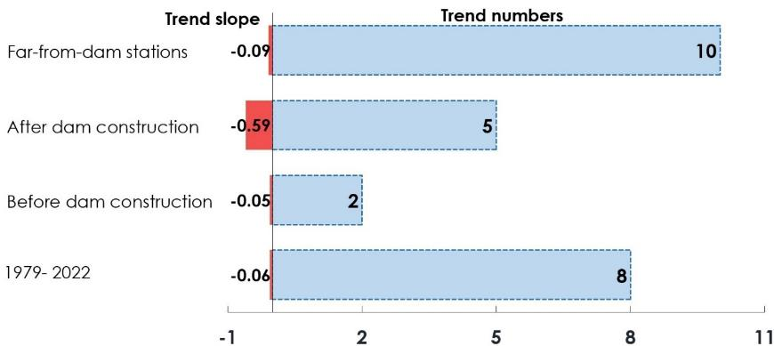
Figure 8. Average slope and number of discharge trends in proximal and distal sampling points.

Correlations were calculated using the Pearson coefficient to assess the influence of damming and drought on discharge variability in a daily, monthly, seasonal, and annual discharge trends. Pairwise correlation analysis between proximal and distal points to the dams over the study period (1979–2022) revealed generally similar behaviour for both of them (Figure 9).
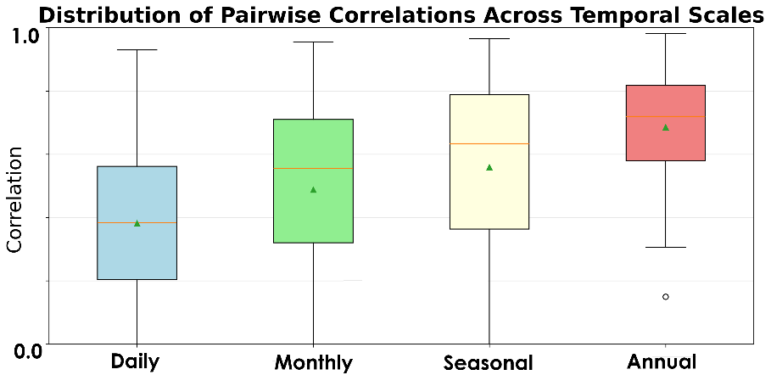 | 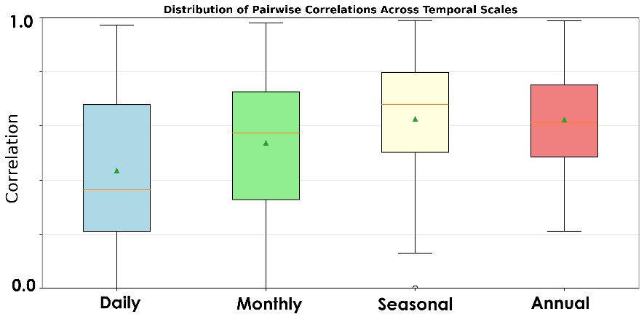
Figure 9. Distribution of pairwise correlation across daily, monthly, seasonal and annual temporal scales for close-dam (right) and far-dam points (left).
The correlation of discharge trends increased from daily to annual scales at proximal points, while at distal ones the order was daily, monthly, annual, and seasonal. Distal points showed stronger correlations at daily to seasonal scales, whereas annual correlations were higher at proximal points (Figure 10). Lower short-term correlations at proximal points reflect fluctuations from dam regulation, while higher seasonal correlations at distal points indicate stronger links between discharge and precipitation. Points D39 and D88 (northwest TEB) and points 2 and 3 (southwest TEB) exhibited consistently high correlations due to similar climatic and topographic conditions, whereas points 4 and 5 in the north showed weaker annual correlations under differing drought conditions. Overall, these results suggest that after dam operations, discharge variability near dams became more influenced by regulated releases than by local climate, while distal flows remained more climate-driven.
(a)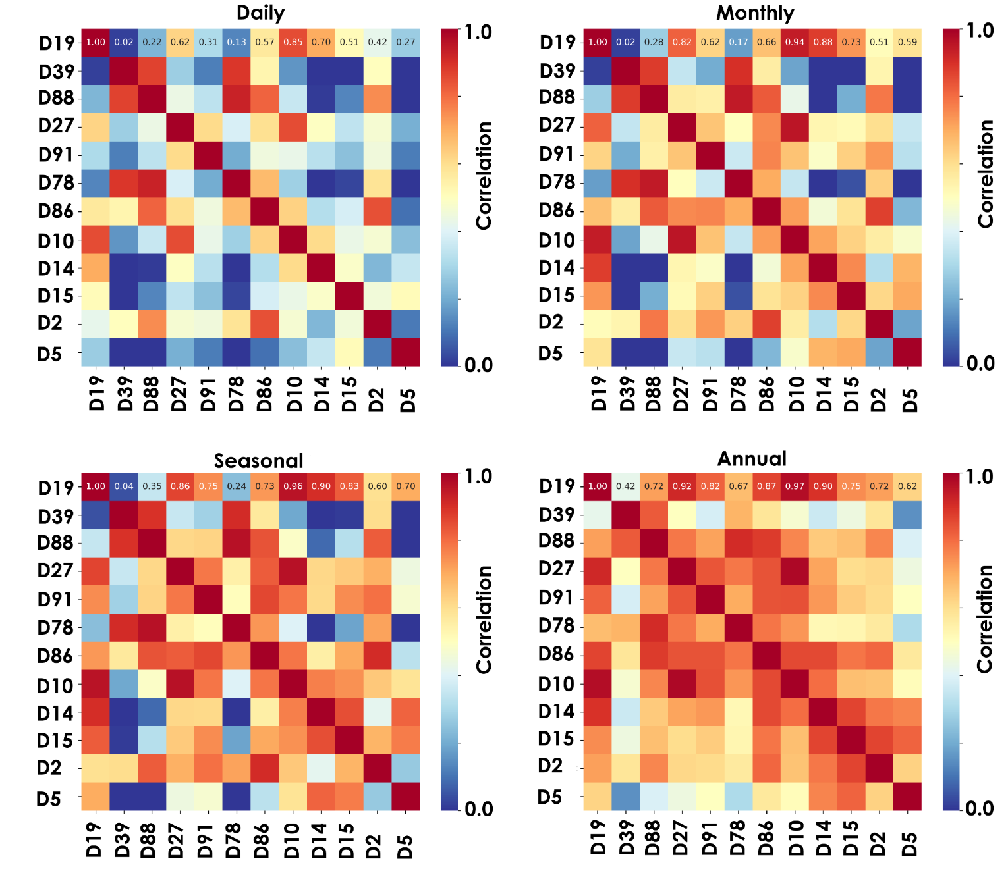 | (b)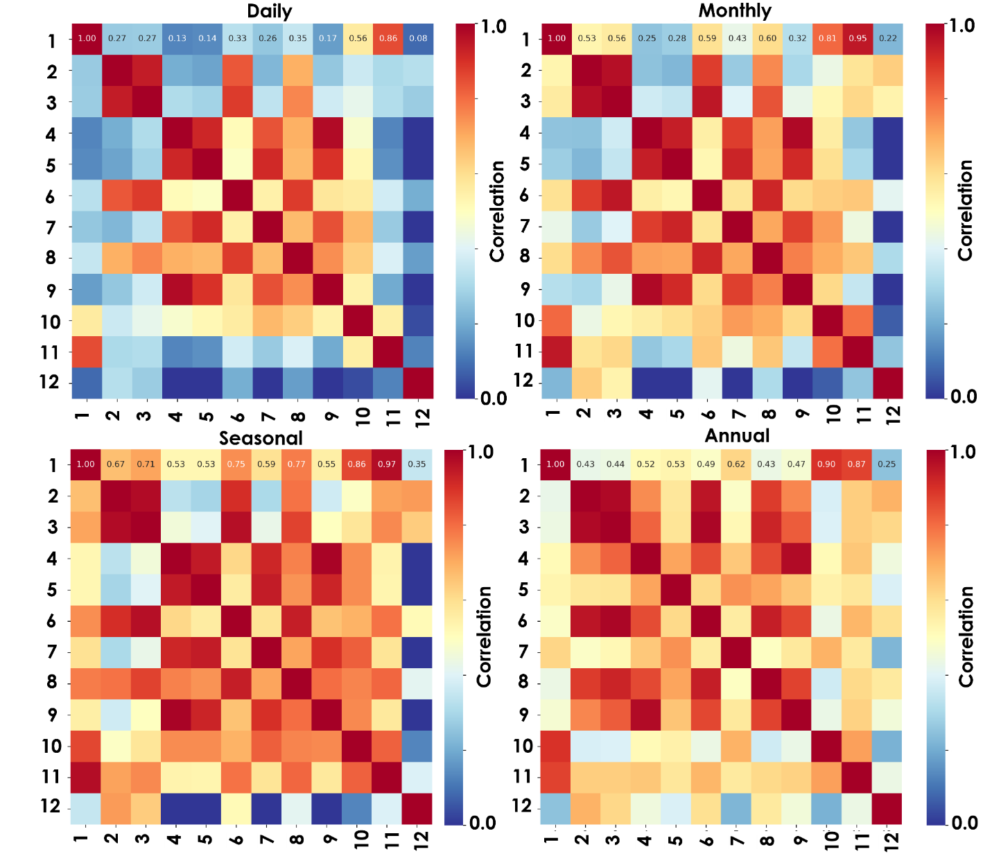
Figure 10. Daily, monthly, seasonal and annual discharge correlation for proximal (a) and distal (b) points.
The radar chart (Figure 11) compares normalized average discharge, PDSI, and their correlations for selected proximal sample points before and after dam construction. While discharge changes are subtle, correlations between discharge and PDSI increased for most points, and PDSI values decreased sharply. These shifts suggest altered hydrological responses to drought following dam operation.
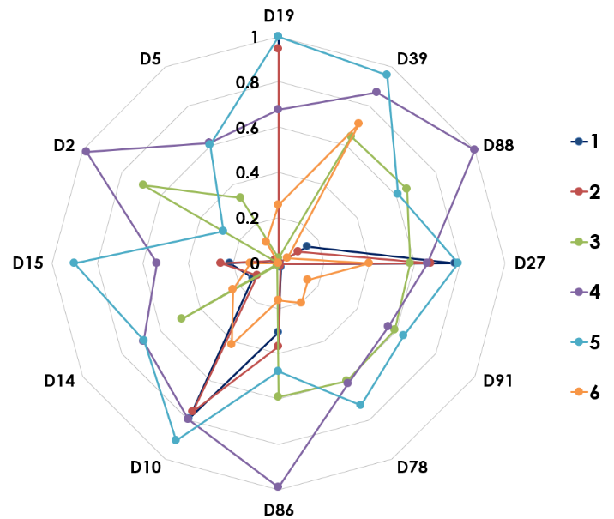 | average discharge before dam construction  average discharge after dam construction  correlation of discharge and PDSI before dam construction  correlation of discharge and PDSI after dam construction  average PDSI before dam construction  average PDSI after dam construction
Figure 11. Radar chart shows average discharges and PDISs as well as their correlations for proximal points before and after dam operations.

Results from proximal and distal points reveal distinct hydrological responses in the TEB. Proximal sample points show sharper discharge reductions and immediate seasonal flow alterations, closely aligned with dam operation dates, confirming strong local impacts of dam regulation. Distal points also experienced declining discharges and altered seasonality but with more gradual changes and stronger correlations with PDSI, indicating dominant climatic influences. The delayed and weaker response downstream suggests buffering effects from tributary inflows and local water management. Overall, damming has created localized zones of major hydrological alteration, while climate change exerts broader regional effects across the basin. These combined impacts underscore the need for integrated water management that accounts for both dam-induced and climatic drought. As shown in Figure 12, average discharge decreased after construction for all dam types—hybrid, irrigation, and hydropower—with irrigation dams causing greater proportional reductions, though hydropower dams produced larger absolute decreases due to their storage volumes.
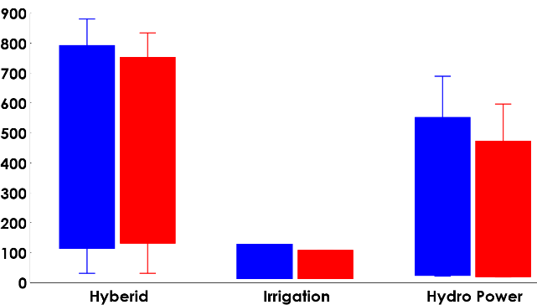
Figure 12. Average discharge before (blue) and after (red) dam constructions for proximal points regarding the dam functions
As a consequence of upstream damming which led to flow reduction in both Tigris-Euphrates basins as discussed, the downstream areas faced severe water scarcity issues. These issues led to various other issues such as crop failure, water-induced migration, agricultural droughts, land degradation, farmland loss, desertification, groundwater recharge reduction, hydropower shortage, loss of fish and river biodiversity, drying of marshlands, and intrastate conflicts between regions and even farmers. Consequently, these issues may lead to increasing political tension between upstream and downstream countries of TEB. Therefore, the result of this study could be used as an effective tool for water diplomacy between riparian countries in negotiations. Furthermore, it could also be a powerful tool for making a formal agreement of transboundary cooperation.
5. Conclusion
This study analysed the daily discharge time series for both proximal and distal sampling points alongside monthly PDSI records (1979–2022) to assess the impacts of damming and drought on the Tigris and Euphrates River flows. Results show that dam operations cause immediate and substantial reductions in discharge and alter seasonal flow patterns near the dams, while drought exerts a more widespread influence across the basin. The combined effects of damming and climate variability have contributed to a significant decline in water resources, exacerbating downstream water scarcity. Differences between proximal and distal points highlight the spatially heterogeneous impacts of anthropogenic and climatic pressures. These findings underscore the need for integrated water management strategies and regional cooperation among riparian countries to mitigate adverse effects on river flow, ecosystems, and communities. Future research should focus on hydrological modelling of dam operations and drought impacts to improve sustainable water resource management in this arid and semi-arid region.
Acknowledgements: This work was supported by the Iran National Science Foundation (INSF) under projects (402069) and (4021582). The authors also thank the General Department of Natural Resources and Watershed Management of Alborz Province for their valuable support.
References
Abatzoglou, J. T., Dobrowski, S. Z., Parks, S. A., & Hegewisch, K. C. (2018). TerraClimate, a high-resolution global dataset of monthly climate and climatic water balance from 1958–2015. Scientific data, 5(1), 1-12.
Abdelmohsen, K., Sultan, M., Save, H., Abotalib, A. Z., Yan, E., & Zahran, K. H. (2022). Buffering the impacts of extreme climate variability in the highly engineered Tigris Euphrates river system. Scientific Reports, *12*, Article 4178. https://doi.org/10.1038/s41598-022-07891-0.
Adamo, N., Al-Ansari, N., & Sissakian, V. (2020). How dams can affect freshwater issues in the Euphrates-Tigris basins. Journal of Earth Sciences and Geotechnical Engineering, 10(1), 43-76.
Al-Ansari, N., AlJawad, S., Adamo, N., Sissakian, V. K., Laue, J., & Knutsson, S. (2018). Water quality within the Tigris and Euphrates catchments. Journal of Earth Sciences and Geotechnical Engineering, 8(3), 95-121.
Al-Ansari, N., Jawad, S., Adamo, N., & Sissakian, V. (2019). Water quality and its environmental implications within Tigris and Euphrates rivers. Journal of earth sciences and geotechnical engineering, 9(4), 57-108.
Al-Hudaib, H., Adamo, N., Bene, K., Ray, R., & Al-Ansari, N. (2025). Application of decision support systems to water management: The case of Iraq. Water, 17(12), 1748. https://doi.org/10.3390/w17121748
Al- Shaabani, M. M. H., & Nashed, R. S. A. (2025). Effects of climate change on drainage and water security of the Euphrates River in Iraq: Challenges and prospects for the future. Journal of Tikrit University for Humanities, *32*(3), 112–134
Altinbilek*, D. (2004). Development and management of the Euphrates–Tigris basin. International Journal of Water Resources Development, 20(1), 15-33.
Azizi, M. A., & Leandro, J. (2025). Factors Affecting Transboundary Water Disputes: Nile, Indus, and Euphrates–Tigris River Basins. Water (20734441), 17(4).
Bakhtiari, M., Darvishi Boloorani, A., Kakroodi, A. A., Rangzan, K., & Mousivand, A. (2021). Land degradation modeling of dust storm sources using MODIS and meteorological time series data. Journal of Arid Environments, 190, 104507.
Beaumont, P. (1978). The Euphrates River—An international problem of water resources development. Environmental Conservation, 5(1), 35-43.
Bilgen, A., & Mason, M. (2026). Hydro-transparency and transboundary water governance: Addressing information deficits and asymmetries in the Euphrates–Tigris Basin. Environmental Science & Policy, 180, 104392. https://doi.org/10.1016/j.envsci.2026.104392
Darvishi Boloorani, A., Papi, R., Soleimani, M., Karami, L., Amiri, F., & Samany, N. N. (2021). Water bodies changes in Tigris and Euphrates basin has impacted dust storms phenomena. Aeolian Research, 50, 100698.
Darvishi Boloorani, A., Papi, R., Soleimani, M., Samany, N. N., Al-Hemoud, A., Bakhtiari, M., ... & Huete, A. (2026). Human interventions and climate change trigger water crisis in the Tigris and Euphrates Basin. Environmental Science & Policy, 177, 104300.
Dai, A. (2011). Characteristics and trends in various forms of the Palmer Drought Severity Index during 1900–2008. Journal of Geophysical Research: Atmospheres, 116(D12).
Eiriksdottir, E. S., Oelkers, E. H., Hardardottir, J., & Gislason, S. R. (2017). The impact of damming on riverine fluxes to the ocean: A case study from Eastern Iceland. Water Research, 113, 124-138.
El‐Fadel, M., Sayegh, Y. E., Ibrahim, A. A., Jamali, D., & El‐Fadl, K. (2002). The Euphrates–Tigris Basin: A case study in surface water conflict resolution. Journal of Natural Resources and Life Sciences Education, 31(1), 99-110.
Fu, Y., Zhu, Z., Liu, L., Zhan, W., He, T., Shen, H., ... & Ao, Z. (2024). Remote sensing time series analysis: A review of data and applications. Journal of Remote Sensing, 4, 0285.
Geng, L., Che, T., Wang, X., & Wang, H. (2019). Detecting spatiotemporal changes in vegetation with the BFAST model in the Qilian Mountain region during 2000–2017. Remote Sensing, 11(2), 103.
González-Cao, J., Fernández-Nóvoa, D., de Castro, N. G., Barreiro-Fonta, H., de Castro, M., & Gómez-Gesteira, M. (2026). Impact of dams on river regime and extreme flow events in Miño–Sil river basin (NW of the Iberian Peninsula). CATENA, 264, 109836. https://doi.org/10.1016/j.catena.2026.109836
Graf, W. L. (2006). Downstream hydrologic and geomorphic effects of dams: Case studies from the United States. Geomorphology, 79(3-4), 264-283.
Grill, G., Lehner, B., Thieme, M. et al. (2019). Mapping the world’s free-flowing rivers. Nature 569, 215–221. https://doi.org/10.1038/s41586-019-1111-9
Haas, E. M., Bartholomé, E., & Combal, B. (2009). Time series analysis of optical remote sensing data for the mapping of temporary surface water bodies in sub-Saharan western Africa. Journal of Hydrology, 370(1-4), 52-63.
Harrigan, S., Zsoter, E., Alfieri, L., Prudhomme, C., Salamon, P., Wetterhall, F., ... & Pappenberger, F. (2020). GloFAS-ERA5 operational global river discharge reanalysis 1979–present. Earth System Science Data Discussions, 2020, 1-23.
Hashemi, M., Rouhi, H., & Ahmadi, A. (2024). Forecasting the area of water resources of the Tigris and Euphrates River basin in 2040 and the effects of water reduction on geopolitical conflicts. Journal of Crisis Studies of the Islamic World, *11*(4), 145–162. https://journals.abru.ac.ir/article_719682.html?lang=en
Hussein, O. A., & Mohamed, K. (2021). Legal Rights of International Water Resources: A Case of Tigris and Euphrates Rivers. International Journal of Law, Government and Communication, 6(22), 130-137.
Issa, I. E., Al-Ansari, N. A., Sherwany, G., & Knutsson, S. (2013). Trends and future challenges of water resources in the Tigris–Euphrates Rivers basin in Iraq. Hydrology and Earth System Sciences Discussions, 10(12), 14617-14644.
Kamidis, N., Koutrakis, E., Sapounidis, A., & Sylaios, G. (2021). Impact of river damming on downstream hydrology and hydrochemistry: The case of lower Nestos River catchment (NE. Greece). Water, 13(20), 2832.
Kibaroglu, A., & Scheumann, W. (2013). Turkey's water policy and the Southeastern Anatolia Project (GAP). In Water policy in Turkey (pp. 1-20). Springer.
Kim, S. (2026). An indicator-based framework for monitoring and assessing ecological flows downstream of dams. Environmental Monitoring and Assessment, 198, 439. https://doi.org/10.1007/s10661-026-15290-5
Kondolf, M., & Yi, J. (2022). Dam Renovation to Prolong Reservoir Life and Mitigate Dam Impacts. Water, 14(9), 1464. https://doi.org/10.3390/w14091464
Latif, Sarmad Dashti. (2025). Protect Iraq’s Mesopotamian Marshes. Science, 390(6773), 581. https://doi.org/10.1126/science.aeb1912
Latif, Sarmad Dashti. (2026). Bridging Technology and Diplomacy: The Role of AI in Managing Water Scarcity in the Mesopotamian Region. World Water Policy, 12(1). https://doi.org/10.1002/wwp2.70065
Lehner, B., Liermann, C. R., Revenga, C., Vörösmarty, C., Fekete, B., Crouzet, P., ... & Robertson, J. C. (2011). Global reservoir and dam (grand) database. Technical Documentation, Version, 1, 1-14.
Li, J., Li, Z. L., Wu, H., & You, N. (2022). Trend, seasonality, and abrupt change detection method for land surface temperature time-series analysis: Evaluation and improvement. Remote Sensing of Environment, 280, 113222.
Lu, X. X., & Chua, S. D. X. (2021). River discharge and water level changes in the Mekong River: Droughts in an era of mega‐dams. Hydrological Processes, 35(7), e14265.
Luan, W., Li, X., Kuang, W., Su, J., Xue, H., Zhang, K., ... & Li, G. (2025). Quantitative Assessment of the Water Stress in the Tigris–Euphrates River Basin Driven by Anthropogenic Impacts. Remote Sensing, 17(4).
Mendes, M. P., Rodriguez-Galiano, V., & Aragones, D. (2022). Evaluating the BFAST method to detect and characterise changing trends in water time series: A case study on the impact of droughts on the Mediterranean climate. Science of The Total Environment, 846, 157428.
Nielsen, A. A. (2002). Multiset canonical correlations analysis and multispectral, truly multitemporal remote sensing data. IEEE transactions on image processing, 11(3), 293-305.
Oktav, Ö. Z. (2017). Turkey’s water policy in the Euphrates-Tigris basin. Environmental change and human security in Africa and the Middle East, 239-255.
Ozguler, H., & Yıldız, D. (2020). Consequences of the droughts in the Euphrates-Tigris Basin. International Journal of Water Management and Diplomacy, 1(1), 29-40.
Petts, G. E. (1984). Impounded rivers: perspectives for ecological management. John Wiley & Sons.
Piwowar, J. M., & LeDrew, E. F. (2002). ARMA time series modelling of remote sensing imagery: A new approach for climate change studies. International Journal of Remote Sensing, 23(24), 5225-5248.
Richter, B. D., Baumgartner, J. V., Powell, J., & Braun, D. P. (1996). A method for assessing hydrologic alteration within ecosystems. Conservation Biology, 10(4), 1163-1174.
Shiklomanov, I. A. (1997). Assessment of water resources and water availability in the world. Comprehensive Assessment of the Freshwater Re-sources of the World.
Shamseddin, M. A., & Elmeski, H. A. (2022). Mapping dynamic changes in hydrological time series using the average directional index. International Journal of River Basin Management, 20(1), 67-78.
Stoffers, T., Schultze, A.-K., Ehlert, T., Kaiser, L., Scholz, M., & Nagelkerke, L. A. J. (2026). Challenges and opportunities in restoring European free-flowing rivers. Nature Conservation, 62, 355–381. https://doi.org/10.3897/natureconservation.62.173762
Sun, H., Ge, W., Ma, F., Li, Z., Zhang, Y., Xia, M., Wang, J., & van Gelder, P. (2025). Analysis of the time-varying characteristics of the relationships and influence degrees among dam economic life influencing factors. Journal of Cleaner Production, 535, 147077. https://doi.org/10.1016/j.jclepro.2025.147077
UN-ESCWA, B. (2013). Inventory of shared water resources in western Asia: United nations economic and social commission for western Asia. Federal Institute for Geosciences and Natural Resources, Beirut. Lebanon.
Unver, I. O. (1997). Southeastern Anatolia Project (GAP). International Journal of Water Resources Development, 13(4), 453-484.
Verbesselt, J., Hyndman, R., Newnham, G., & Culvenor, D. (2010). Detecting trend and seasonal changes in satellite image time series. Remote sensing of Environment, 114(1), 106-115.
Voss, K. A., Famiglietti, J. S., Lo, M., De Linage, C., Rodell, M., & Swenson, S. C. (2013). Groundwater depletion in the Middle East from GRACE with implications for transboundary water management in the Tigris‐Euphrates‐Western Iran region. Water resources research, 49(2), 904-914.
Ward, J. V., & Stanford, J. A. (1995). Ecological connectivity in alluvial river ecosystems and its disruption by flow regulation. Regulated rivers: research & management, 11(1), 105-119.
Warner, J. (2012). The struggle over Turkey’s Ilısu Dam: domestic and international security linkages. International Environmental Agreements: Politics, Law and Economics, 12, 231–250. https://doi.org/10.1007/s10784-012-9178-x
Wen, L., Rogers, K., Ling, J., & Saintilan, N. (2011). The impacts of river regulation and water diversion on the hydrological drought characteristics in the Lower Murrumbidgee River, Australia. Journal of Hydrology, 405(3-4), 382-391.
Zaghiyan, M. R., Delavar, M., Shokri Kuchak, V., & Morid, S. (2026). Hydrological impacts of climate and water management in the Tigris–Euphrates transboundary basin. Journal of Hydrology: Regional Studies, 65, 103460. https://doi.org/10.1016/j.ejrh.2026.103460
Zargar, A., & Abbasi Alamooti, F. (2023). The security-environmental effect of the GAP project (Turkey) on downstream countries; considerations of International Law. Quarterly Journal of West Asian Studies (Faṣlnāmah-i Gharb-i Asiyā), 1(1), 73-85.

